**India’s agricultural crop production**

***Tntroduction***

1.1 Overview

Agriculture in India started with the Indus valley civilization. It is mentioned in the history of India that rice and cotton were the two crops that were cultivated in the Indus valley.

It is the world's largest producer of milk, pulses, and spices, and has the world's largest cattle herd (buffaloes), as well as the largest area under wheat, rice and cotton. It is the second largest producer of rice, wheat, cotton, sugarcane, farmed fish, sheep & goat meat, fruit, vegetables and tea.

Crop models are a formal way to present quantitative knowledge about how a crop grows in interaction with its environment. Using weather data and other data about the crop environment, these models can simulate crop development, growth, yield, water, and nutrient uptake.

1.2.pupose of Indian agriculturecrop production

Agriculture is the practice of cultivating plants and livestock in order to provide facilities the human beings. In the rise of the sedentary human lifestyle agriculture was the key development. The cultivation of plant and food grains began years ago in order to provide food to the city population. Agriculture is the main need for the people to live in the society. Agriculture is the main source of livelihood, it provides a source for the people to earn. Most of the population in the rural areas is dependent on agriculture as their main source of income.

Foodgrains included the grains or cereals that have been used for eating. Fiber crops are completely Commercial, they can not be eaten and are completely grown for making money. Raw materials are that category of crops that are completely grown for use as raw materials in industries in order to prepare other items.

Problem Definition & Design Thinking

2.1 Empathy Map:

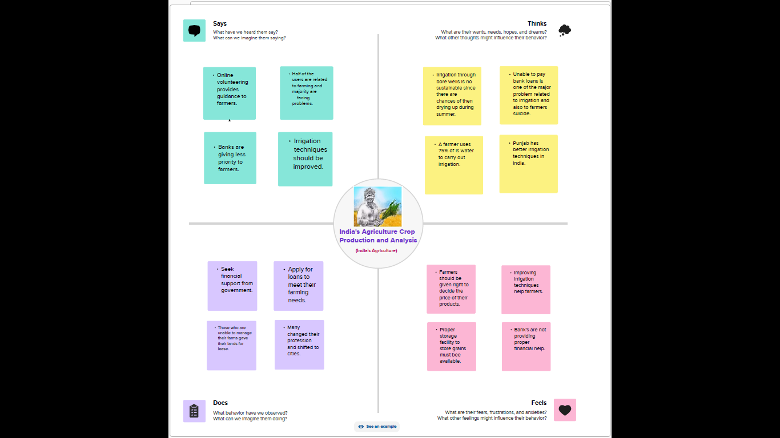

2.2 Ideation & Brainstorming Map:

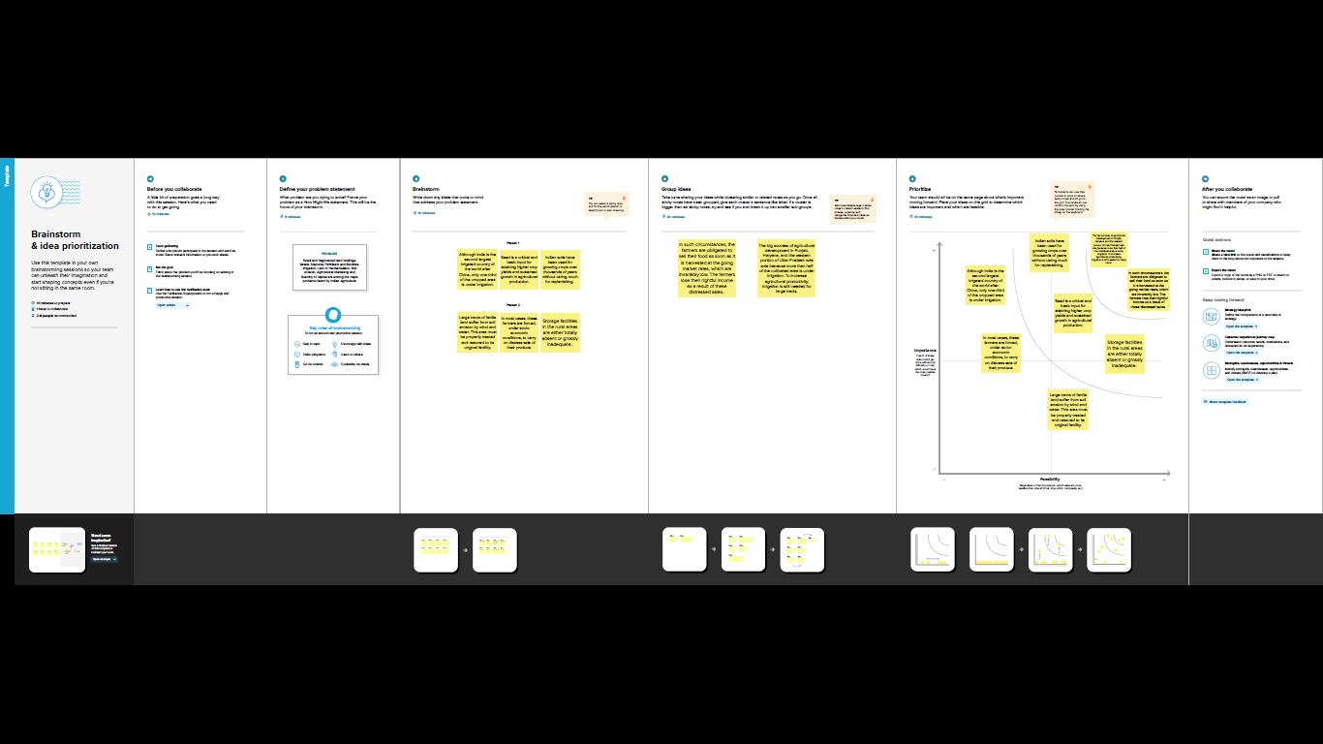

## Disadvantage

## environmental degradation: Intensive agriculture can lead to soil erosion, deforestation, water pollution, and loss of biodiversity. Depletion of natural resources: Agriculture can lead to the depletion of natural resources such as water and soil, and can lead to land degradation and desertification.

## advantage

## It provides employment opportunity to the rural agricultural as well as non-agricultural labourers. It is the source of food and fodder. It also plays an important role in international business in import and export activities.

**Application**

Crop production is the process of growing crops such as grains, fruits, vegetables, and nuts. The goal of crop production is to produce a high yield of quality crops that can be sold or used for food, feed, fuel, and fiber.

[Agri App](https://krishijagran.com/agriculture-apps/agriapp/) is a total farmer-friendly app that provides **complete information on Crop Production**, **Crop Protection, and all relevant agriculture-allied services**. It also enables farmers to access all the information related to **“High value, low product”** category crops from varieties, soil/ climate, harvesting, and storage procedures. Moreover, an option to chat with experts, video-based learning, the latest news, and online markets for , insecticides, etc. are also available on this app

## Output results

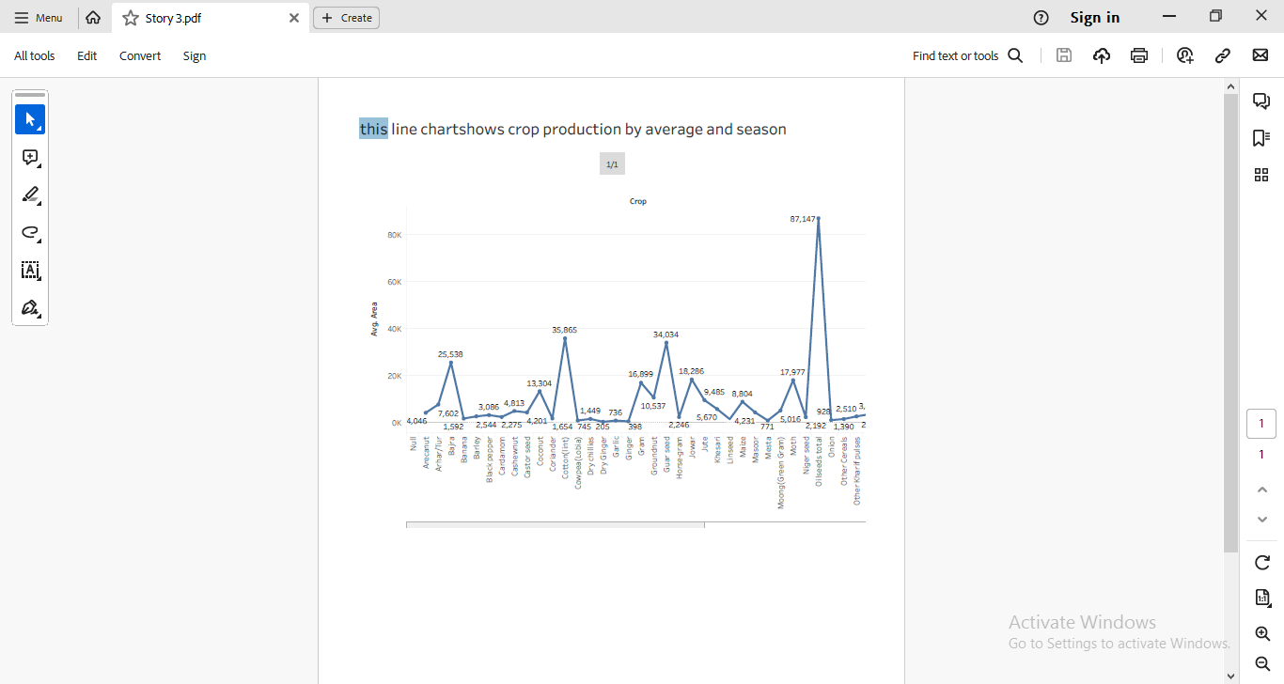

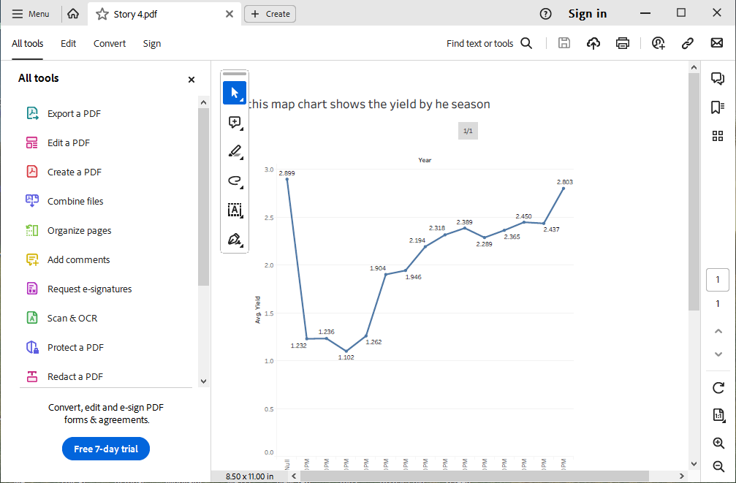

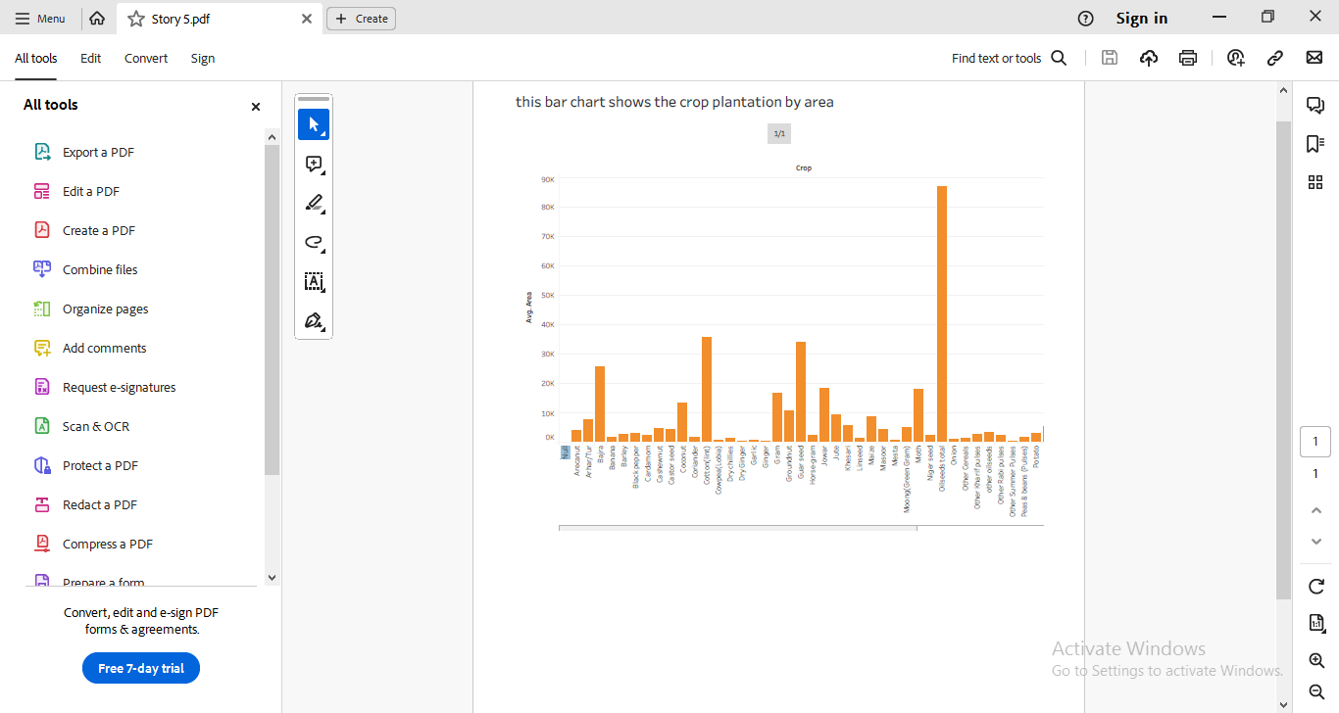

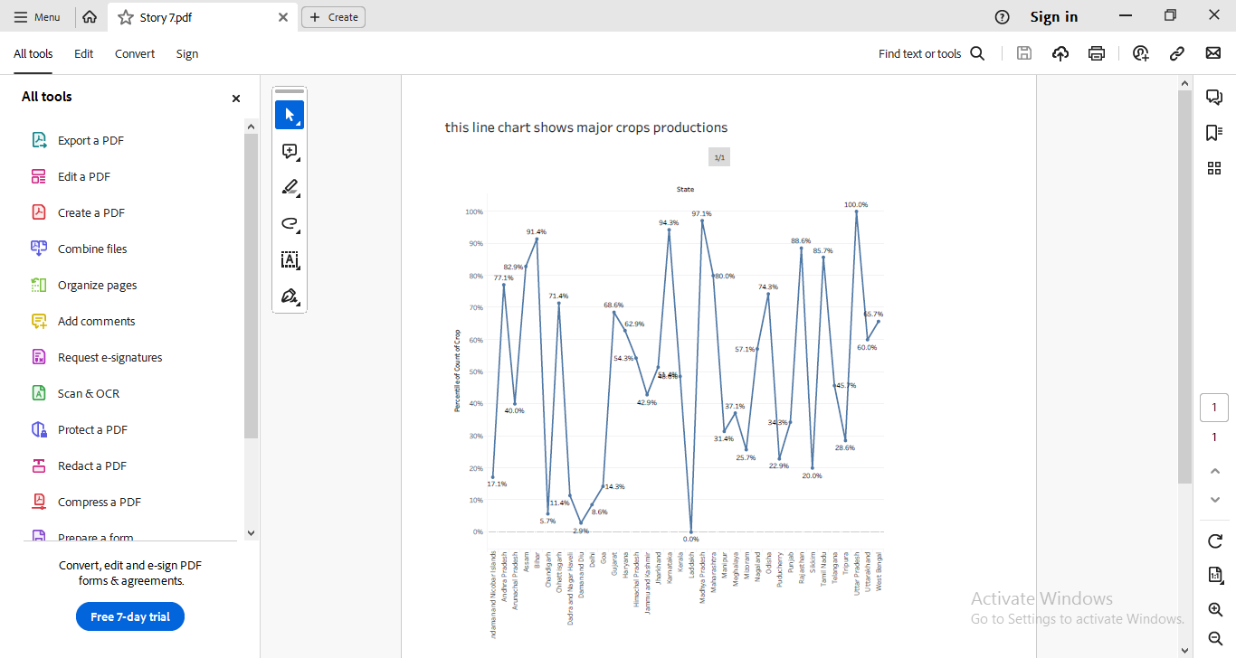



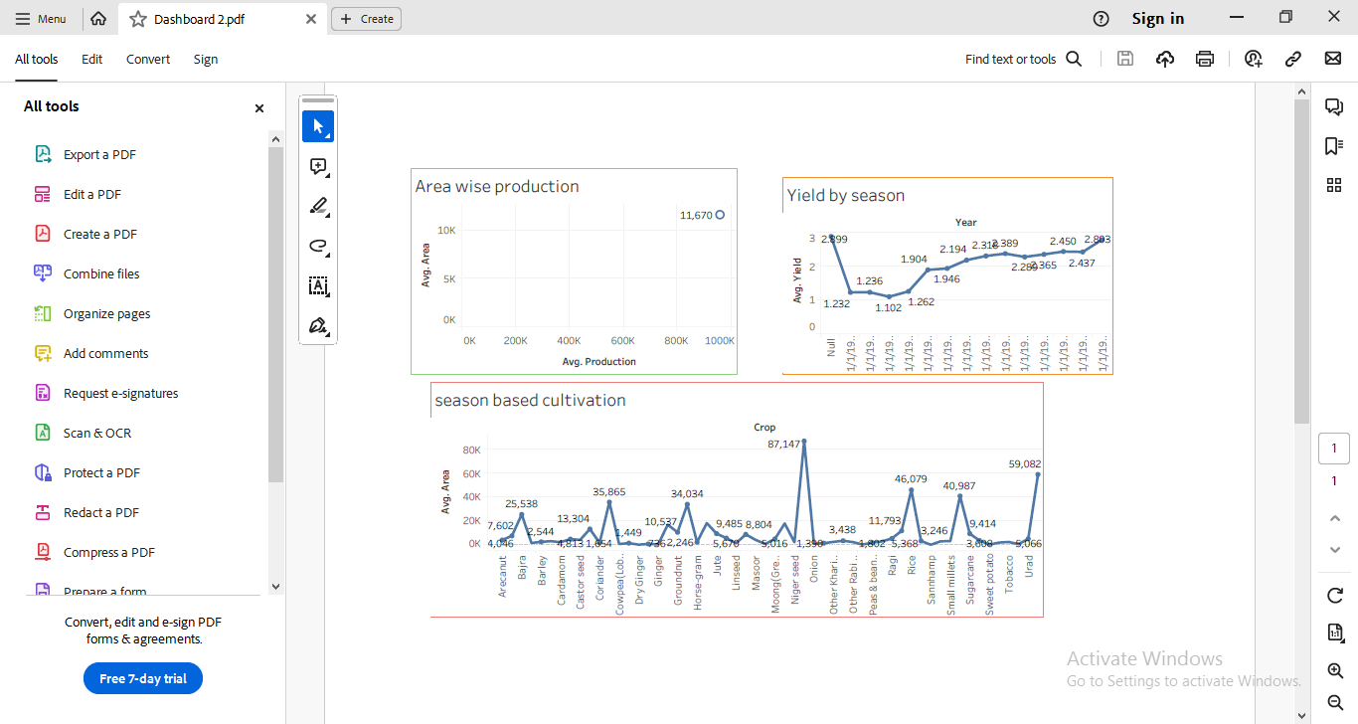

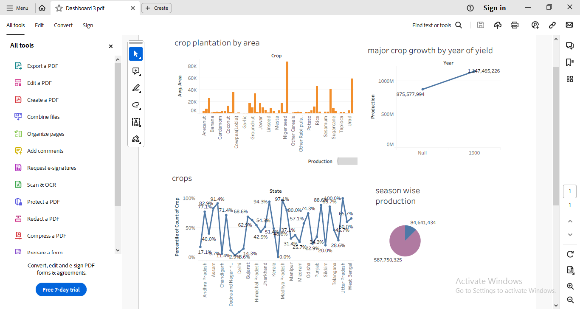

**Conclusions**

1. The country has made significant progress in the adoption of modern methods of cultivation and creating infrastructure for effectively and sustainably utilizing the national resources available at its command.
2. It has transformed its image from that of a ‘begging bowl’ to bread basket due to the efforts of various agencies combined with scientific and engineering inputs in agriculture.
3. Indian agriculture has evolved into a mature and modern enterprise over the last five decades. Farm mechanization has reached a level of maturity pushing the net sales of machinery to over Rs 50,000 crore, almost entirely through indigenous efforts.
4. Farm mechanization programmes pursued in the country after attaining independence were directed towards optimal utilization of available farm power sources. The impact of tractorization as against oxenisation is evident from the fact that India is the largest producer of tractors in the world.
5. Increase in cropping intensity, timeliness of operations and reduction in drudgery have been shown to be the needed incentives for farmers and farm workers to adopt modern methods of cultivation.
6. An increase of 15 per cent in productivity and a reduction of 20 per cent in the cost of cultivation can be achieved by engineering interventions.

**Future scope** There will be more of vertical and urban farming and there will also be efforts in long term to find new areas for production like barren deserts and seawater. Precision farming with soil testing-based decisions, automation using artificial intelligence will be focused for precise application inputs in agriculture.There is a tremendous scope for agriculture because food & food products are indispensable for the survival of humanity. It's a recession proof industry because when every industry is downsizing the demand for food crops is on a rise underlining the need for agricultural productivity.